**SHARING FILE BETWEEN WINDOWS & LINUX:**

Here I use SCP protocol to transfer files. SCP (Secure Copy Protocol) is a network protocol used to securely transfer files between a local host and a remote host, or between two remote hosts. SCP uses SSH (Secure Shell) for data transfer, which ensures that the file transfer is encrypted and secure. It is commonly used in Linux and Unix environments but is also available on Windows systems through tools like PuTTY or WinSCP

**STEP 1: Make sure your windows have openssh server installed on it.**

Go to Apps & features -> optional features -> Add a features.

Make sure to install OpenSSH Server.





**STEP 2: Start the OpenSSH service (Because it does not start by deafault).**

Go to services In Computer management. Search for open SSH server,double click it & change the startup type from manual to Automatic.

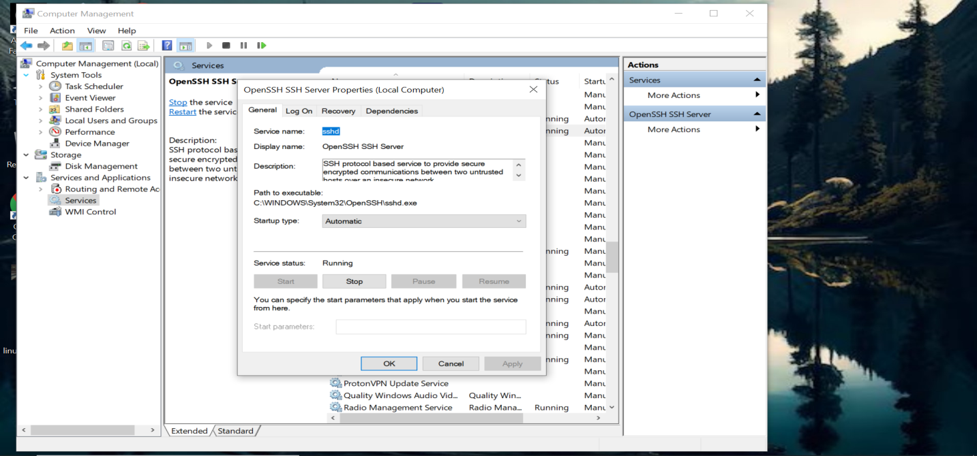

**STEP 3:** **Install OpenSSH** by command **sudo apt install openssh-server**

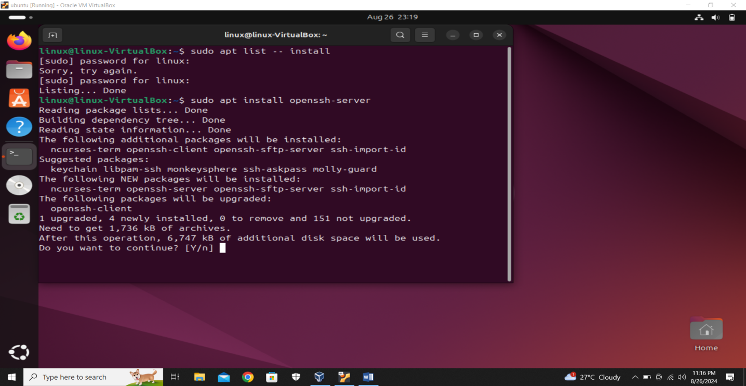

**STEP 4: Check OpenSSH installed or not** by command **sudo apt list --installed | grep openssh-server**

And checkif ssh service is activate or not by command **sudo service ssh status**

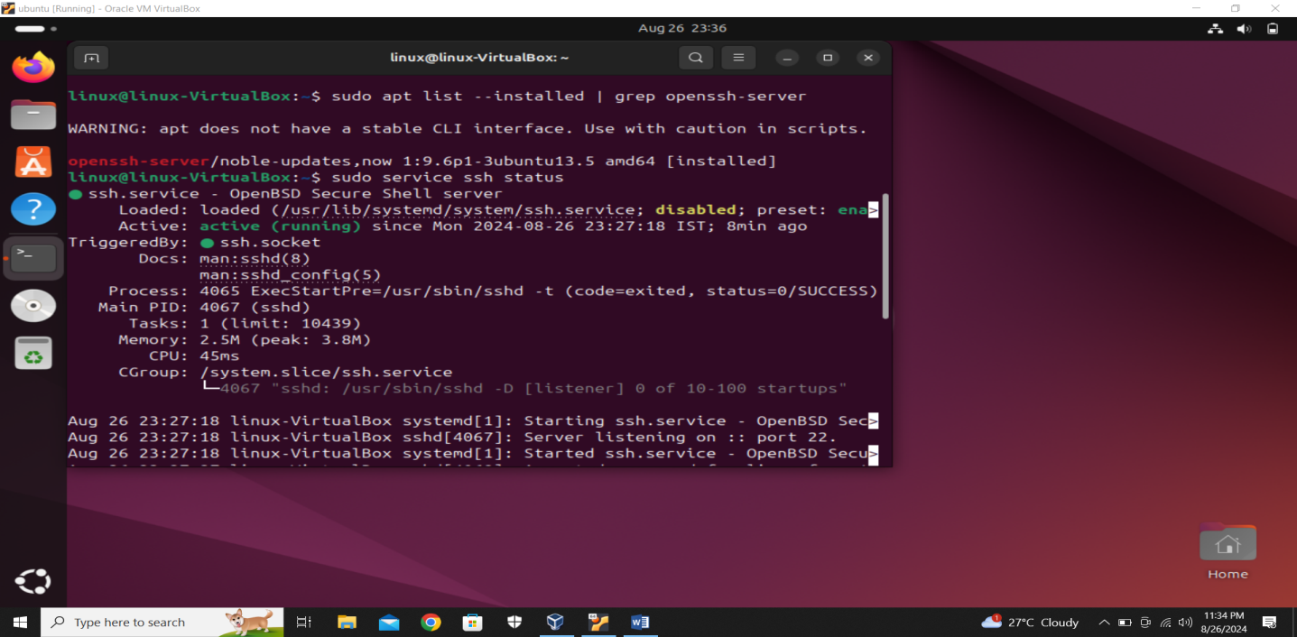

Now we know that SSH is enable on both linux and windows

**STEP 5:** Now open linux terminal and type command: **scp filename windows user name@ip address of the windows:C:\Users\user\Desktop**

Here target windows user name is **‘user’** and ip address is **192.168.0.106**

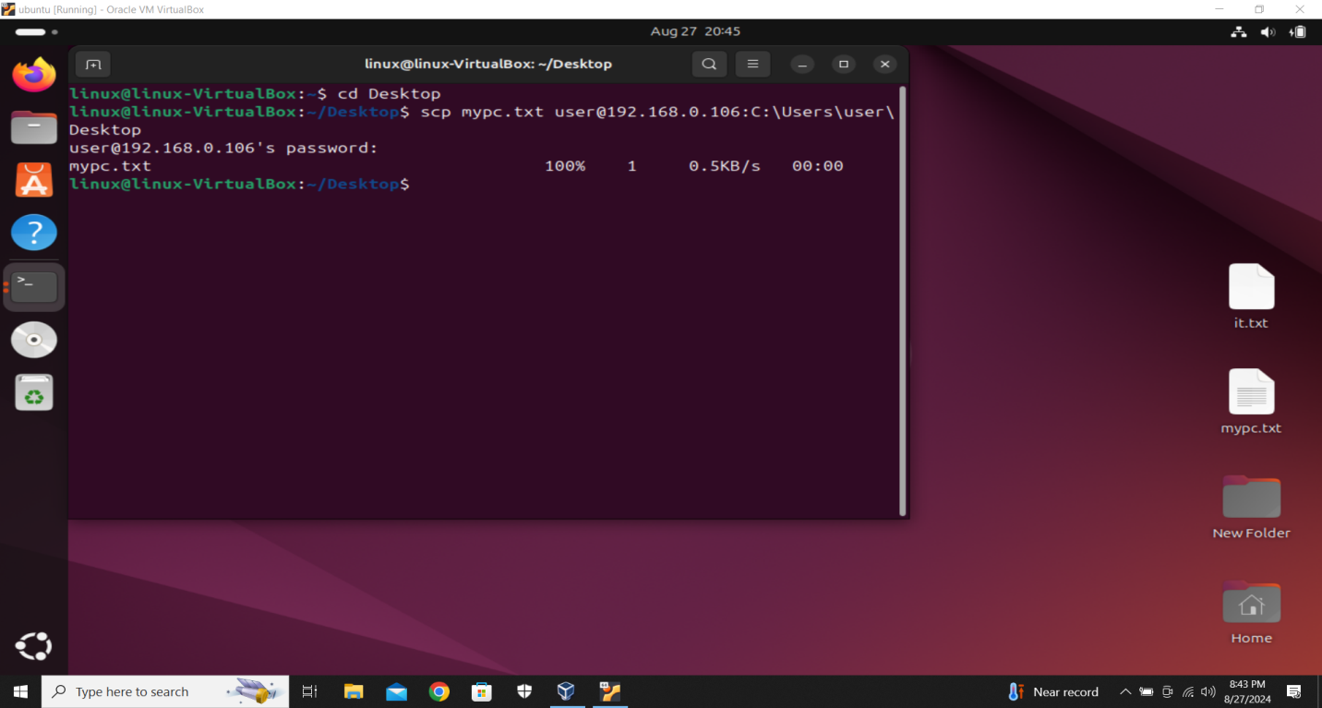

**STEP 6:** Now open Wndows terminal and type command: **scp filename linux user name@ip address of the linux:/home/linux/Desktop/**

Here target Linux user name is **‘linux’** and ip address is **192.168.0.109**

